Project Design Phase-II Technology Stack (Architecture & Stack)

|  |  |
| --- | --- |
| Date | 03 October 2022 |
| Team ID | PN2022TMD41919 |
| Project Name | SmartFarmer- IOT Enabled Smart Farming Application |
| Maximum Marks | 4 Marks |

Technical Architecture:

USER CLOUD FIELD

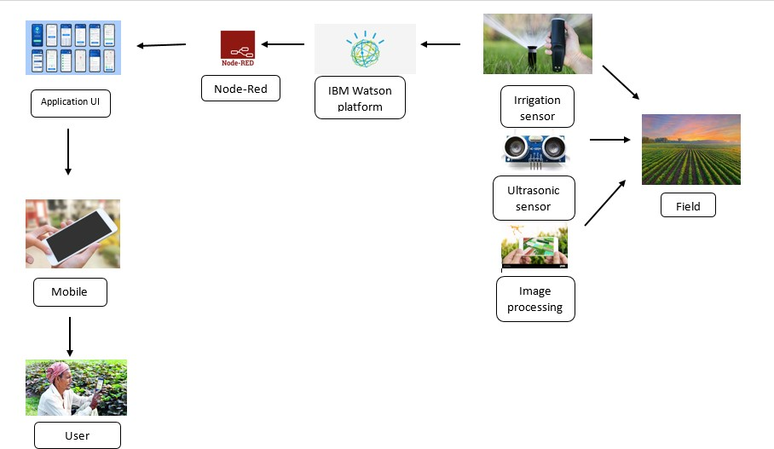

**Table-1:**

**Components & Technologies:**

|  |  |  |  |
| --- | --- | --- | --- |
| **S.No** | **Component** | **Description** | **Technology** |
|  | Mobile Application | Through the mobile application, user get to know all live data from the devices. | MIT inventor |
|  | Web UI | It is used as WebSocket communication in binary mode between the web browser (UI) and your application. | Node red, Python |
|  | IBM Watson | Use your data to create, train, and deploy self-learning models. Leverage an automated, collaborative workflow to build intelligent applications. | IBM Watson STT service |
|  | IBM Watson Assistant | Watson Assistant lets you build conversational interfaces into any application, device, or channel | IBM Watson Assistant |
|  | Ph sensor | It used for sensing the Ph level of the soil | sensor |
|  | Ultra-sonic sensor | It detects the animal movement in the soil | Sensor |
|  | Temperature Sensor | It collects the data of the temperature and humidity of the environment | Sensor |
|  | Soil Moisture Sensor | It collects water level in soil | sensor |
|  | Database | Data Type, Configurations etc. | MySQL, NoSQL, etc. |
|  | Cloud Database | Database Service on Cloud | IBM DB2 |
|  | Cloud Storage | It is used for File and data storage | IBM Block Storage |
|  | Open weather API | It provides highly recognizable weather product that make working with weather data a way easier | IBM Weather API |
|  | Aadhar API | It can authenticate the Aadhaar cards of any other individual without any issue | Aadhar API |
|  | Infrastructure (Server / Cloud) | Application Deployment on Local System / Cloud  Local Server Configuration,  Cloud Server Configuration. | Local, Cloud Foundry, Kubernetes. |

**Table-2: Application Characteristics:**

| **S.No** | **Characteristics** | **Description** | **Technology** |
| --- | --- | --- | --- |
|  | Open-Source Frameworks | The open-source framework is a set of tools that can be used to create websites, user interfaces and basic software applications. | Mozilla Firefox\GNU\Linux |
|  | Security Implementations | Application security  Data security | SHA-256/Encryptions/IAM Controls/OWASP. |
|  | Scalable Architecture | Each segment or functional unit of the divided IoT application, performs a separate function. | **Microservices Architecture** |